Module 9-2

2)

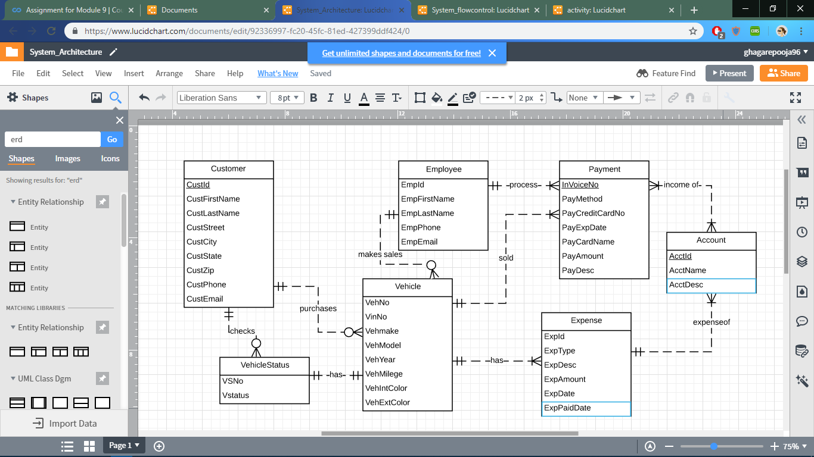

* The vehical status is deferred from vehical entity to vehical status
* A relationship between customer and vehical status exist
* The minimum cardinality between the payment and account is changed from 0 to 1
* Many attributes and constraints changes are also needed